**LOCAL DATABASE**

**Before reading, note the following details about the Local Database. Note that the Local Database is meant to store data offline should the user not have internet access. A lot of the functionalities of the app will still be functioning even in offline mode. This is the purpose of this Local Database.**

USER

The USER table is simply a table that stores user information like the User ID or Nickname. It is not related to any other database in terms of relationship and it should NOT be. It is used in conjunction with other local tables in order to do online queries. Think of the USER table as a shared preference from android studio that’s what it basically is. We were not aware of share preferences earlier on the project and only recently came into knowledge of it, hence why it is there and not separated in share preferences.

LECTURER

The LECTURER table is used to store information, well about the lecturers. It is used in conjunction with other tables and is often references (the Lecturer_ID) as a foreign key. The information about the LECTURER table is also to display the courses details for the user’s course and show the user the lecturers email address for quick reference.

COURSE

This table stores the user’s current course he/she is enrolled in. If the user is a lecturer, it will be assumed that the lecturer is “enrolled” in the course in order to provide the same functionality as it would for a student.

The course tables stores the name and the course code of the user’s courses at WITS. The courses are gathered by the “WITS_COURSE” Database and the user has NO influence in the courses that is provided by the app.

REIGISTERED

Linking the COURSE table and the LECTURER table together is the REIGISTERED table. The reason this table exists in the Local Database is so that when displaying the user’s course, the respective email address for each course’s lecturer will be displayed, naturally a lecturer can have more than one course to teach hence the existence of this table.

MESSAGE

Onto the fun tables! The MESSAGE table stores all “messages” that a lecturer adds, it is uploaded to the Online Database and when the student has internet access. He/She will receive all the messages sent out by the lecturer. Naturally, only lecturers can send out messages. Users cannot. *(They more like informal emails … basically)*

TEST

The make or break part of every student’s day… The TEST table stores the current users’ tests details. Welp, this paragraph’s word count is as low as some of my test percentages. ☹ lol just joking… hopefully…

USER_TASK

Stores any tasks made from the user, if a student made a task it will go here. If a lecturer chooses to store a task that only he wants to see he can. Only the user will have access to this task, and it will never ever see the light of the Online Database. Can contain a due date or due time and even course code!

LECTURER_TASK

USER_TASK more formal brother, LECTURER_TASK gets all the attention of the Online Database. Literally every task in this database is from the Online Database. Naturally only lecturer can add to this table.

**LOCAL DATABASE TOUCH UP**

**In the next page is a picture of the Local Database and its relationships. It will be discussed in the next page.**

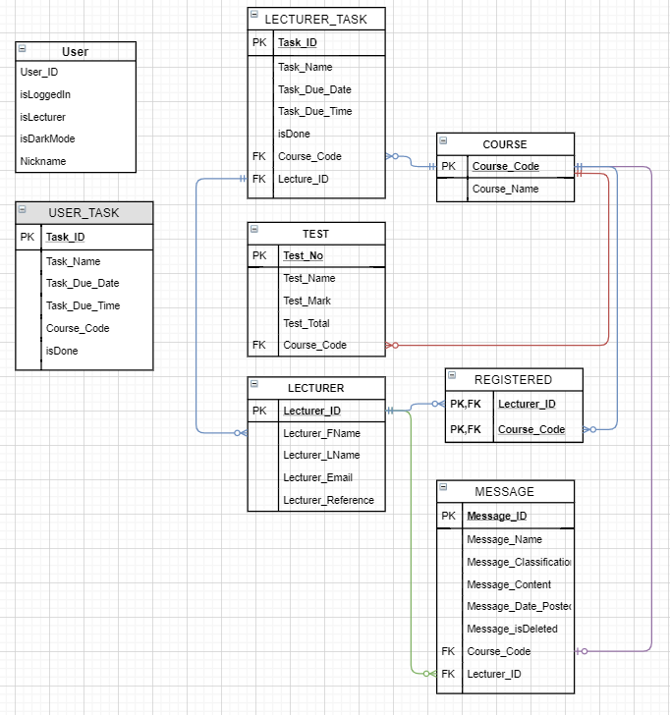

*“They say a picture is greater than a thousand words”*

Even though this Local Database is meant to only store data. We have ensured that the relationships are properly defined between them similarly, if not exactly like that of its Online Database counterpart.

All attributes for each table is properly defined to ensure that the data is not incorrectly inserted in any possible away… or else…

**Error Main: FATAL**

**error Sqlitedatabse** *(followed by 3 billion lines)*

In my opinion, the Local Database fills its purpose of simply saving data from the Online Database. It ensures the integrity on the data due to the relationships. The Online Database is **not** dependant on any Local Database in **any way**. Therefore, it poses no security risk at all. The Local Database is **heavily** dependent on the Online Database. It regularly syncs whenever it has the chance too (well not literally whenever it can, but often enough) .

There is nothing much else to be said about the database, the last thing left is to show how each attribute for each table is defined and the relationships amongst the tables. This will be in the next page.

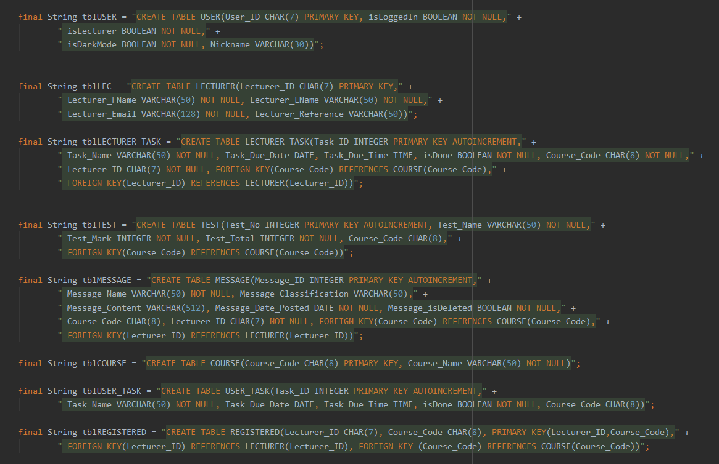

*There is also a landscape version on the next page*

**